**INTEGRATED CONTEXT ANALYSIS**

*Overlay of maps for context-specific programme design*

**What is the ICA?**

The Integrated Context Analysis (ICA) is an analytical process that contributes to identify and discuss the most appropriate programmatic strategies in specific geographical areas – including **resilience building**, **disaster risk reduction**, **social protection** and **emergency preparedness** – for the most vulnerable and food insecure populations.

Historical trend analyses of **food security** and **natural shocks** are combined to identify areas of convergence, and aggravating factors – such as **land degradation** – are overlaid on top of them to further inform programming.

The ICA also includes other layers – nutrition, seasonality, livelihood, food insecure population estimates – that provide a set of lenses used to pinpoint the geographical areas where further in-depth analyses are needed.

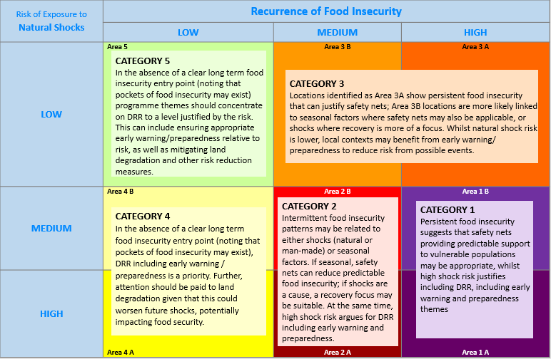

**Who carries out the ICA?**

The ICA is a joint effort that brings together different subjects and information within WFP:

* Vulnerability Analysis and Mapping (**VAM**) conducts trend analyses on food security, nutrition and market information using VAM and other partner data – such as the Integrated Food Security Phase Classification (IPC) – assessment and monitoring systems in order to triangulate the information and understand the variations.
* **GIS Unit** in the Emergency Preparedness Branch (**OSEP**) uses remote sensing and Geographic Information Systems to model risk based on environmental features and levels of land degradation, population densities and livelihood zones.
* The Direct Implementation Programme Service (**OSZP**) guide the interpretation of these datasets through a programmatic lens and select areas of strategic and programmatic focus in consultation with partners and stakeholders.

**Why should countries run an ICA?**

Used within the broader Three-Pronged Approach (**3PA**), an ICA helps to identify priority areas where to conduct Seasonal Livelihood Programming (**SLP**), consultations to identify area-specific multi-sectorial programmes with government and partners, which in turn set the foundations for targeted joint efforts with communities and partners to plan and implement programmes through Community-Based Participatory Planning (**CBPP**).

**When and where was ICA performed?**

Since 2013, the ICA was performed in over 30 countries, with several countries running updates of the analysis according to changes in the methodology and/or availability of new data.